1. [SELECT](http://192.168.1.12/phpmyadmin/url.php?url=https://dev.mysql.com/doc/refman/5.5/en/select.html" \t "mysql_doc) first\_name, last\_name FROM `actor` ORDER BY first\_name ASC

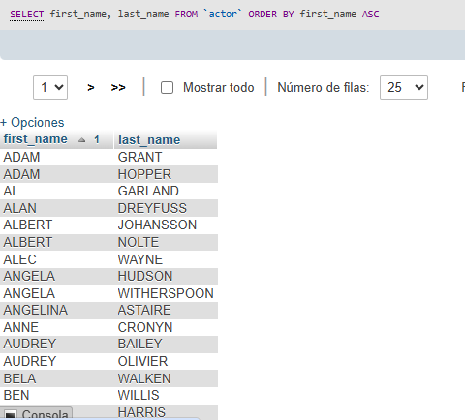

2-